Contents
Proton AG - PRD 2
1. Introduction 2
2. Key Features 2
2.1. Mobile Optimization 2
2.2. Secure Messaging App 2
2.3. Secure File Sharing and Collaboration 2
3. Use Cases 3
3.1 Important Use Case Description 5
4. Functional Requirements 8
4.1. Mobile Optimization 8
4.2. Secure Messaging App 8
4.3. Secure File Sharing and Collaboration 9
5. Minimum Viable Product (MVP) 9
5.1. MVP Features 9
5.2. Hypotheses to Test 9

Proton AG - PRD

Proton AG - PRD

1. Introduction
Proton AG is a leading provider of secure communication services, known for its focus on privacy and security. The Proton Secure Communication Suite aims to expand the Proton product offering by providing a seamless, secure communication experience across multiple platforms and devices. This PRD outlines the key features, use cases, functional requirements, and MVP for this product.

2. Key Features

2.1. Mobile Optimization
Description: To ensure a seamless experience for users across various devices and screen sizes, the Proton Secure Communication Suite will be optimized for mobile usage. This feature will involve responsive design, touch-friendly interfaces, and efficient performance on mobile devices, ensuring that all functionalities are accessible and intuitive on smartphones and tablets.
Value Proposition:
- Provides users with the flexibility to securely access communication tools on the go.
- Ensures that all features are easily accessible on mobile, leading to higher user satisfaction and engagement.

2.2. Secure Messaging App
Description: Expanding beyond email, the Proton Secure Messaging App will offer a comprehensive messaging solution that includes end-to-end encryption for text messages, voice calls, and video calls. This feature aims to provide users with a secure alternative to mainstream messaging apps that may compromise privacy.
Value Proposition:
- Ensures user privacy by providing a secure, encrypted communication platform.
- Differentiates from competitors by focusing on a zero-knowledge approach, where even Proton AG cannot access user communications.

2.3. Secure File Sharing and Collaboration
Description: Proton Docs will be extended to mobile platforms, allowing users to securely create, edit, share, and collaborate on documents from their mobile devices. This feature will integrate seamlessly with the Proton ecosystem, ensuring that all shared files are encrypted and accessible only to authorized users.
Value Proposition:
- Enables secure collaboration on sensitive documents, enhancing productivity without compromising on security.
- Provides a unified platform for secure communication and collaboration, differentiating Proton from competitors that offer standalone solutions.

3. Use Cases
Use Cases based on Key features identified:
Mobile Optimization
Use Case 1: A user accesses their ProtonMail account on their smartphone and experiences a fully responsive interface that adjusts to their screen size.
Use Case 2: A user receives a secure document on their tablet and easily opens it in Proton Docs without needing to switch devices.
Use Case 3: A user participates in a video call via the Proton Secure Messaging App on their phone, with an optimized interface that ensures no features are lost due to screen size.
Secure Messaging App
Use Case 4: A user sends an encrypted text message to another Proton user, ensuring that no third party can intercept the communication.
Use Case 5: A user initiates an encrypted voice call with another Proton user, with the call quality optimized for mobile data networks.
Use Case 6: A user starts a group chat with several Proton users, with all messages and media files being encrypted.
Use Case 7: A user sets an expiration timer on a message, ensuring that it self-destructs after a set period.
Secure File Sharing and Collaboration
Use Case 8: A user creates a new document on Proton Docs via their mobile device and invites a colleague to collaborate in real-time.
Use Case 9: A user securely shares a large file via the Proton Secure Messaging App, with the file being stored in encrypted form on Proton’s servers.
Use Case 10: A user edits a document in Proton Docs on their smartphone, with all changes being automatically saved and encrypted.
Use Case 11: A user accesses previously shared documents on Proton Docs from their mobile device while offline, with encrypted local storage ensuring security.
Use Case 12: A user integrates Proton Docs with their calendar to schedule and collaborate on documents for upcoming meetings.

Some snippets of how the Proton Doc Mobile App should look like.
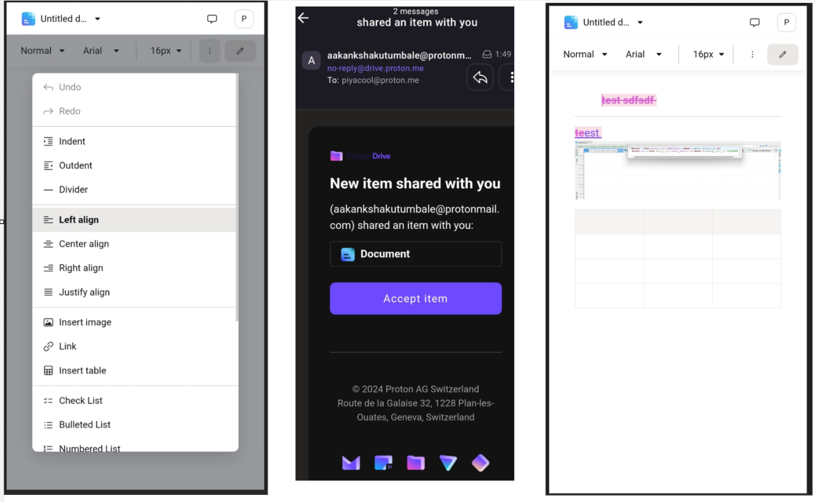

3.1 Important Use Case Description

3.1.1 Use Case: Accessing ProtonMail on Smartphone
- Description: A user logs into their ProtonMail account using a smartphone. The interface adjusts to the smaller screen, providing a smooth, touch-friendly experience without sacrificing functionality.
- Actors: User, ProtonMail app
- Preconditions:
  - The user has a registered ProtonMail account.
  - The ProtonMail app is installed on the smartphone.
- Triggers: The user opens the ProtonMail app on their smartphone.
- Flow of Events:
  - The user opens the ProtonMail app.
  - The app prompts for login credentials.
  - Upon successful login, the app interface adjusts to the smartphone screen size.
  - The user can easily navigate through emails, compose new messages, and manage folders using touch gestures.
- Postconditions: The user can manage their emails seamlessly on their smartphone.
- Alternative Flows:
  - If the device has a weak internet connection, the app should switch to a lower bandwidth mode, displaying only essential elements until the connection improves.

3.1.2 Use Case: Opening a Secure Document on Tablet
- Description: A user receives a secure document via ProtonMail and opens it using Proton Docs on a tablet. The interface is optimized for the larger screen, providing a desktop-like experience.
- Actors: User, ProtonMail app, Proton Docs app
- Preconditions:
  - The user has a registered ProtonMail account and Proton Docs installed.
  - The document has been received in ProtonMail.
- Triggers: The user taps on the document attachment in ProtonMail.
- Flow of Events:
  - The user opens ProtonMail and selects an email with a document attachment.
  - The user taps on the attachment, prompting Proton Docs to open.
  - The document is displayed in a format optimized for tablet screens, allowing for easy reading and annotation.
- Postconditions: The user can view and interact with the document seamlessly on their tablet.
- Alternative Flows:
  - If the document is large, a progress indicator should display as the file loads, with an option to download for offline access.

3.1.3 Use Case: Sending an Encrypted Text Message
- Description: A user sends an encrypted text message to another Proton user through the Secure Messaging App, ensuring that only the intended recipient can read the message.
- Actors: User, Proton Secure Messaging App
- Preconditions:
  - The user and recipient both have the Proton Secure Messaging App installed and are registered users.
- Triggers: The user composes and sends a new message within the app.
- Flow of Events:
  - The user opens the Proton Secure Messaging App.
  - The user selects a contact from their list or enters a recipient's Proton ID.
  - The user composes a message and taps 'Send'.
  - The message is encrypted on the user’s device before being sent over Proton’s servers.
  - The recipient receives the message, which is decrypted only on their device.
- Postconditions: The message is securely sent and can only be read by the recipient.
- Alternative Flows:
  - If the recipient is offline, the message should be stored on Proton’s server in encrypted form until they are online.

3.1.4 Use Case: Starting a Secure Group Chat
- Description: A user starts a secure group chat with multiple Proton users, with all messages and media files encrypted.
- Actors: User, Proton Secure Messaging App
- Preconditions:
  - All participants have the Proton Secure Messaging App installed and are registered users.
- Triggers: The user creates a new group chat in the app.
- Flow of Events:
  - The user selects multiple contacts within the Proton Secure Messaging App.
  - The user creates a new group chat and names it.
  - The app establishes encrypted communication channels with each participant.
  - The user sends a message, which is encrypted and sent to all participants.
- Postconditions: All participants receive the encrypted messages and can respond securely.
- Alternative Flows:
  - If a participant is added after the group chat is created, the app should securely share the chat history with the new participant.

3.1.5 Use Case: Creating a Document on Proton Docs via Mobile
- Description: A user creates a new document in Proton Docs using their mobile device and invites a colleague to collaborate on it in real-time.
- Actors: User, Proton Docs app
- Preconditions:
  - The user has the Proton Docs app installed and is logged in.
  - The user has a Proton account and internet access.
- Triggers: The user selects the option to create a new document within Proton Docs.
- Flow of Events:
  - The user opens Proton Docs on their mobile device.
  - The user selects 'Create New Document'.
  - The document opens with a mobile-optimized interface.
  - The user types content and formats the document using touch controls.
  - The user taps 'Share' and invites a colleague by entering their Proton email.
  - The colleague receives an invitation and joins the document for real-time collaboration.
- Postconditions: Both users can edit and collaborate on the document simultaneously.
- Alternative Flows:
  - If the internet connection is lost, the app should allow offline editing, syncing changes once the connection is restored.

3.1.6 Use Case: Editing a Document on Proton Docs via Smartphone
- Description: A user accesses and edits a document in Proton Docs on their smartphone, with all changes being automatically saved and encrypted.
- Actors: User, Proton Docs app
- Preconditions:
  - The user has the Proton Docs app installed and is logged in.
  - The document is available in their Proton Docs account.
- Triggers: The user opens the document in Proton Docs.
- Flow of Events:
  - The user opens Proton Docs on their smartphone and selects a document.
  - The document opens with a mobile-optimized editing interface.
  - The user makes changes to the document using touch controls.
  - All changes are automatically saved and encrypted in real-time.
- Postconditions: The document is securely updated with the latest changes.
- Alternative Flows:
  - If the document is large, a progress indicator should be shown while loading, and the app should allow partial editing for large documents.

4. Functional Requirements

4.1. Mobile Optimization
- Responsive Design: The interface must dynamically adjust to different screen sizes, orientations, and resolutions.
- Touch-Friendly Interface: Buttons, links, and interactive elements must be large enough and spaced appropriately for touch interaction.
- Performance Optimization: The application must be optimized to perform efficiently on various mobile devices, including those with limited processing power and memory.

4.2. Secure Messaging App
- End-to-End Encryption: All messages, calls, and media must be encrypted using state-of-the-art encryption protocols.
- Zero-Knowledge Architecture: Proton’s servers must be architected in a way that even Proton AG cannot access user communications.
- Cross-Platform Synchronization: Messages and calls must be synchronized across all devices linked to a user’s Proton account, without compromising security.

4.3. Secure File Sharing and Collaboration
- Encryption: All documents and files must be encrypted both in transit and at rest.
- Real-Time Collaboration: Multiple users must be able to edit and comment on a document simultaneously, with all changes being encrypted.
- Offline Access: Users must be able to access and edit documents offline, with changes being synced securely when an internet connection is restored.

5. Minimum Viable Product (MVP)

5.1. MVP Features
- Secure Messaging App: Launch with basic messaging features including text messaging, and end-to-end encryption.
- Mobile Optimization: Ensure that ProtonMail and Proton Docs are fully responsive and optimized for mobile devices.
- Secure File Sharing: Introduce basic secure file sharing features within Proton Docs, with encryption for both shared and stored files.

5.2. Hypotheses to Test
- Hypothesis 1: Users will prioritize security over convenience when it comes to mobile communication and file sharing.
- Hypothesis 2: A seamless, secure messaging experience on mobile will lead to increased user engagement and retention.
- Hypothesis 3: Integration of secure file sharing with mobile optimization will differentiate Proton from competitors and attract privacy-conscious users.

The Proton Secure Communication Suite is designed to enhance the privacy and security of users across mobile platforms, providing them with a comprehensive and differentiated communication experience. By focusing on mobile optimization, secure messaging, and secure file sharing, Proton AG aims to solidify its position as a leader in privacy-focused communication services. The MVP will test key hypotheses around user preferences and product-market fit, guiding future development.

